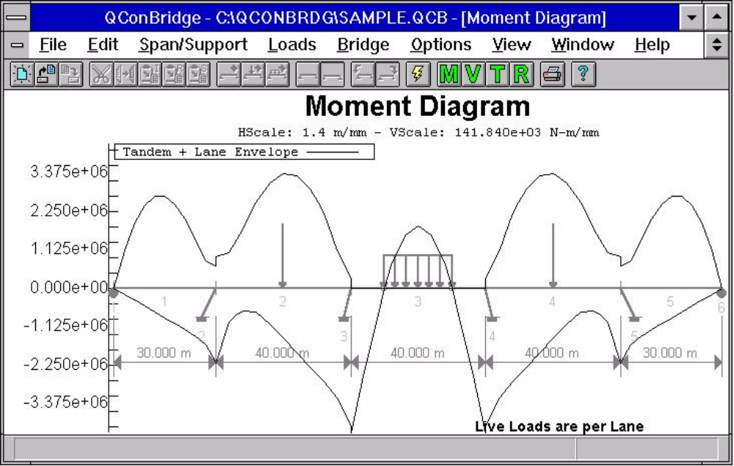
QConBridge is a state of the art bridge analysis tool developed by the WSDOT Bridge and Structures Office Computer Applications Section. This program was developed as part of our efforts to provide the design engineer useful tools to implement the new AASHTO LRFD Bridge Design Specification and to migrate to SI system of units. QConBridge is available from the WSDOT Home Page.

